INDUSTRY – SPECIFIC INTELLIGENT FIRE MANAGEMENT SYSTEM

# Project Design Phase- II Data Flow Diagram & User Stories

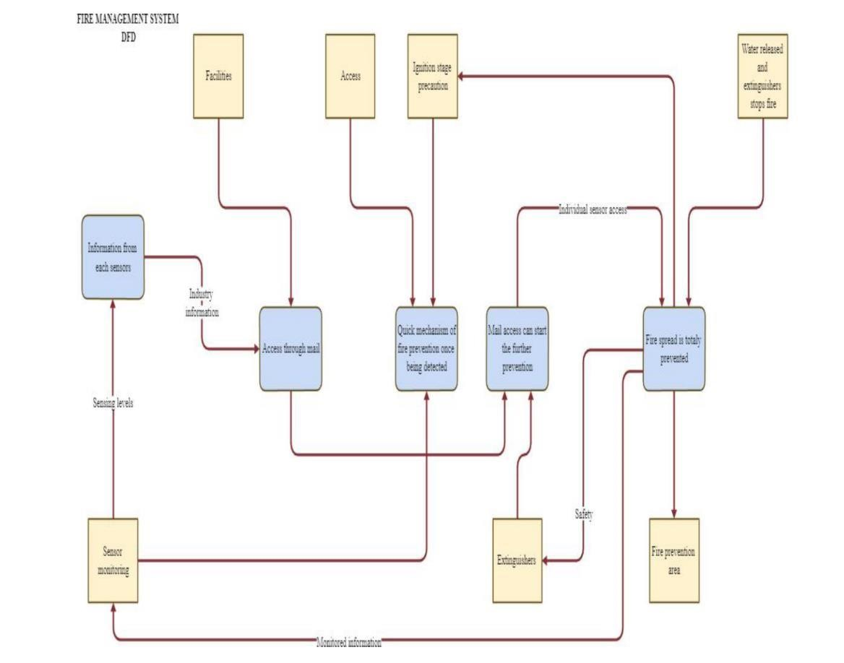

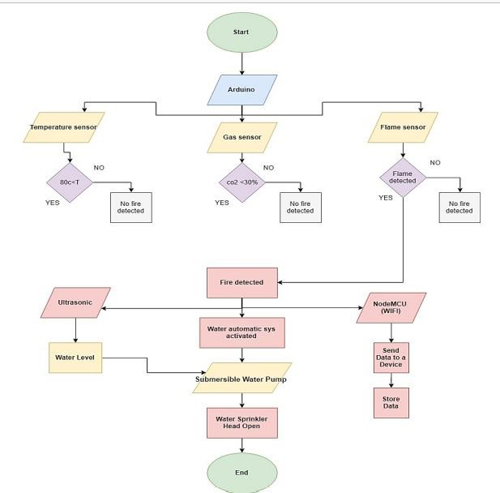

USER STORIES:

|  |  |  |  |  |  |  |
| --- | --- | --- | --- | --- | --- | --- |
| **User Type** | **Functional**  **Requirement** | **User**  **Story**  **Number** | **User**  **Story/Task** | **Acceptance**  **Criteria** | **Priority** | **Release** |
| Customers (Mobile user, web user, care executive,  Administrator) | Registration | USN - 1 | As a user, I can register for the  application  by entering my mail, password, and  confirming my password | I can access my account/ dashboard | High | Sprint - 1 |
|  |  | USN - 2 | As a user, I will receive  confirmation  email once I have  registered for the application | I can receive confirmation email & click confirm | High | Sprint - 1 |
|  | Dashboard | USN - 3 | As a user, I can register for the  application through internet | I can register  & access the dashboard  with Internet login | Low | Sprint - 2 |
|  |  | USN - 4 | As a user, I can register for the  application  through  Gmail | I can confirm the registration in Gmail | Medium | Sprint - 1 |
|  | Login | USN - 5 | As a user, I can log into the  application  by entering email & password | I can login with my ID  & password | High | Sprint - 1 |